Lab 07: Evading IDS

Marko Shaffer

Information Security, Franklin University

ISEC 325: Comm/Network Security

Professor Rick Rozzell

8 / 1 / 2021

# **Lab 07: Evading IDS**

## Follow the instructions from “Lab 07: Evading IDS.”

* + Note: For all of the screenshots in the following steps, make sure to include the entire browser window to show that you are logged in to Netlab.

## Complete the steps in Section 1, “Initialize Network Monitoring Applications.”

## Continue with Section 2, “Test IDS Results with Regular Nmap Scan,” and capture screenshots of the following:

### Step 9 output.

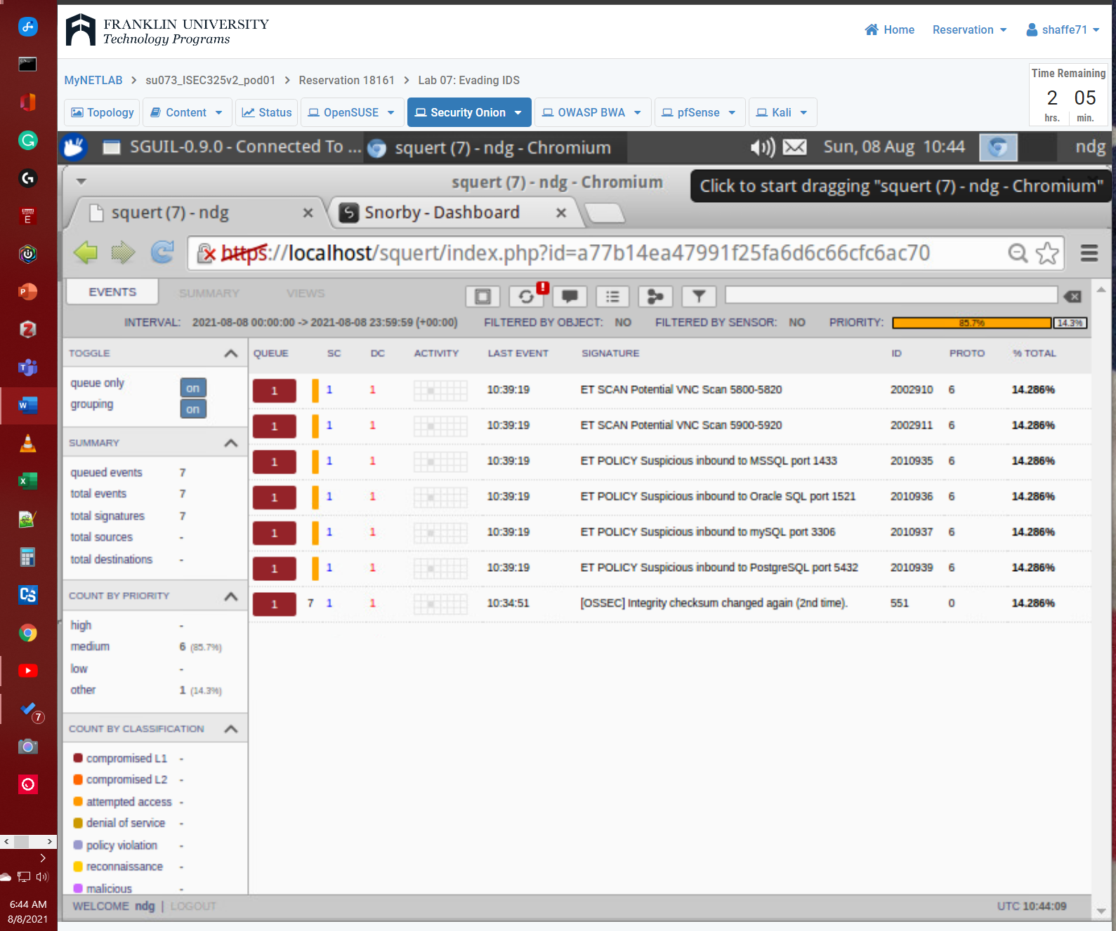

### Step 13 output

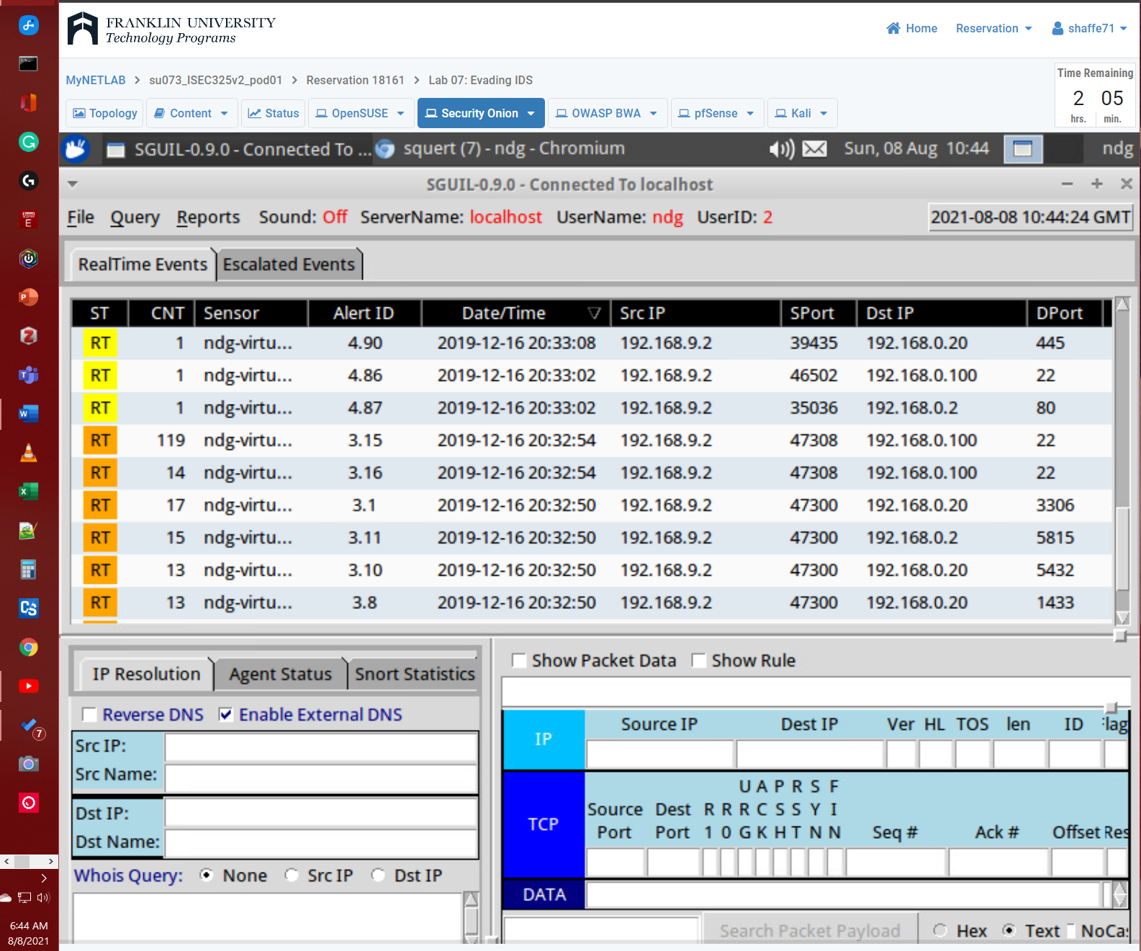

## Continue with Section 4, “Test IDS Results with Decoy Scan,” and capture screenshots of the following:

### Step 6 output

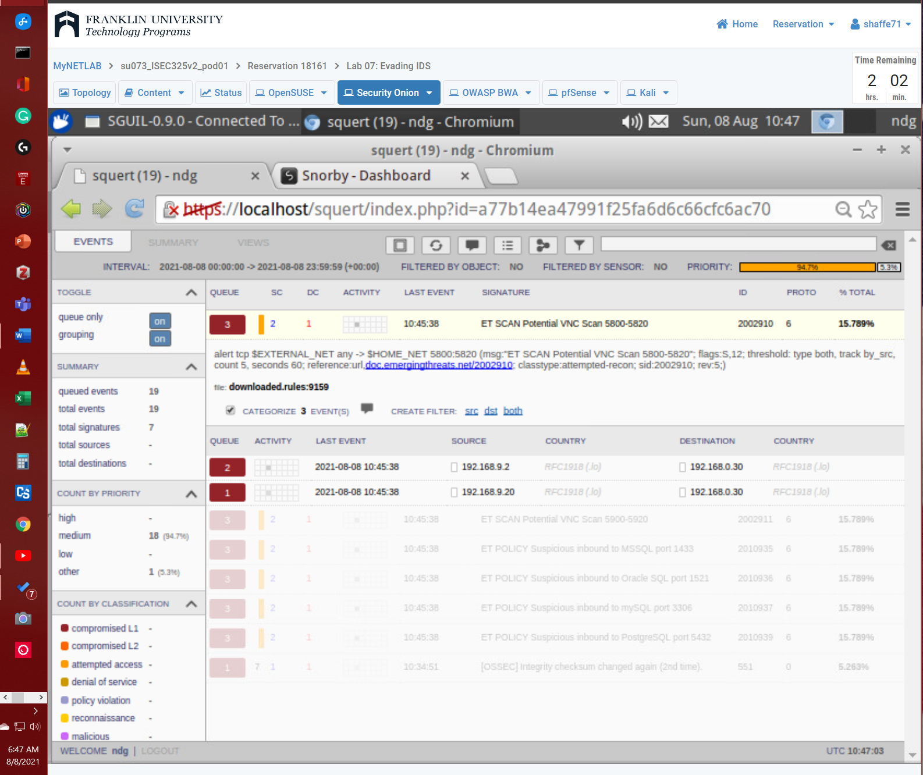

### Step 10 output

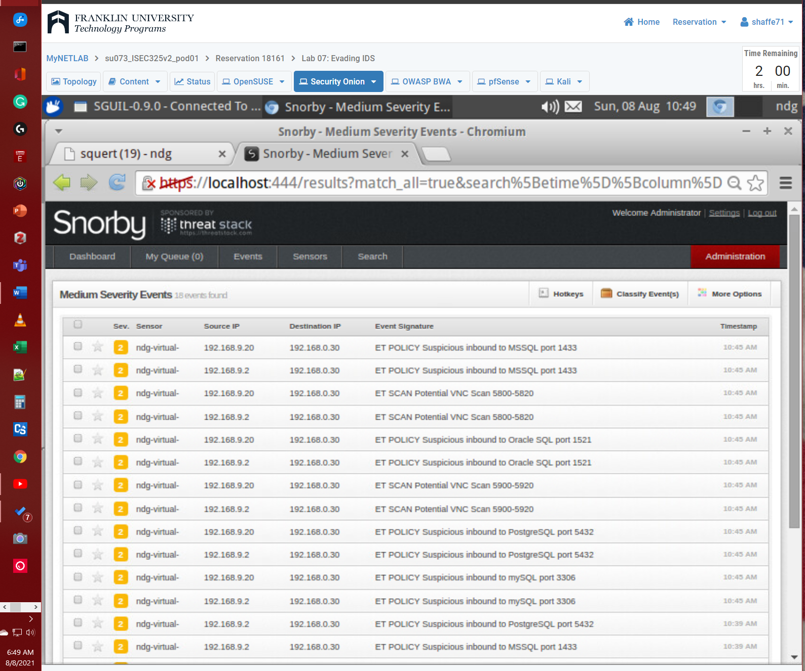

## Continue with Section 5, “Test IDS Results with Spoofed MAC Scan,” and capture screenshots of the following:

### Step 4 Snorby scan output

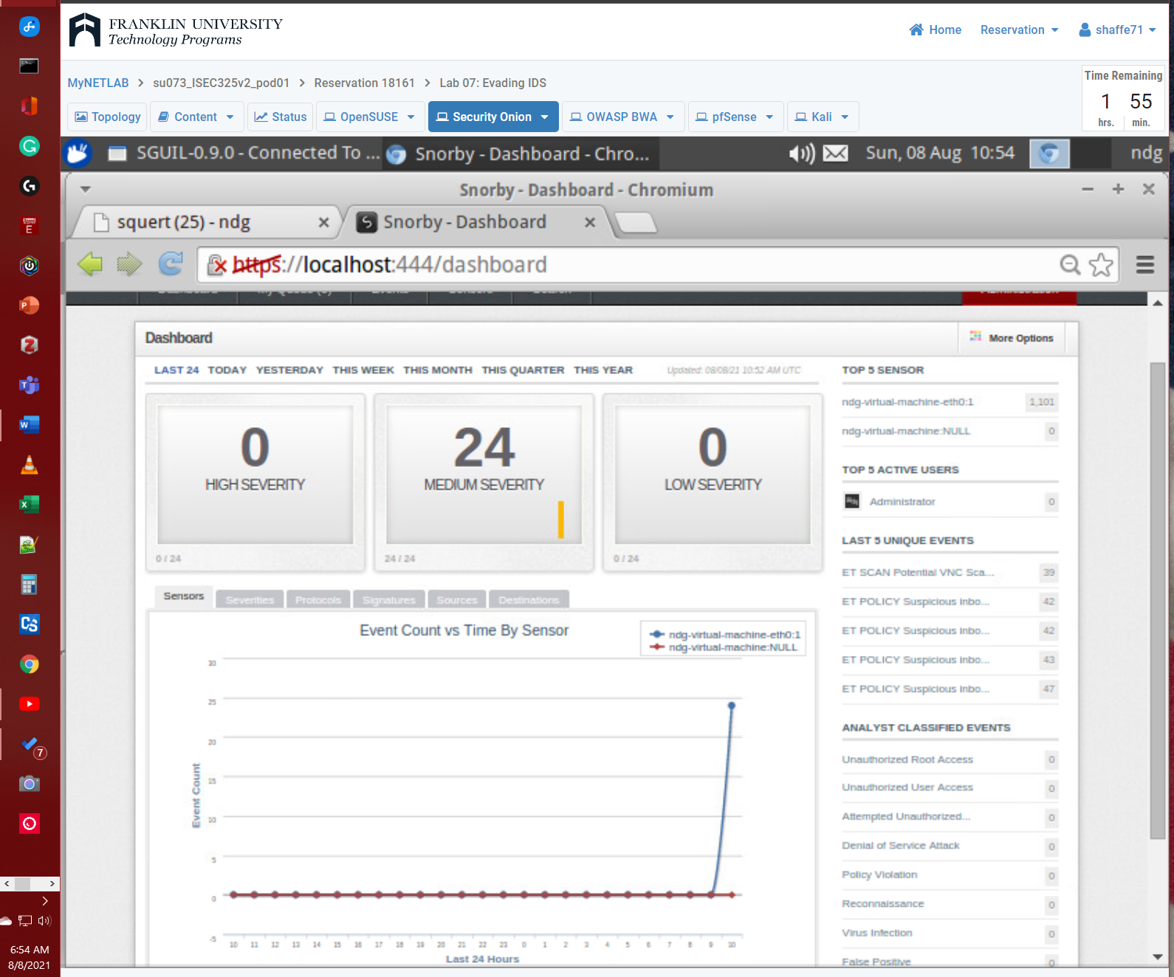

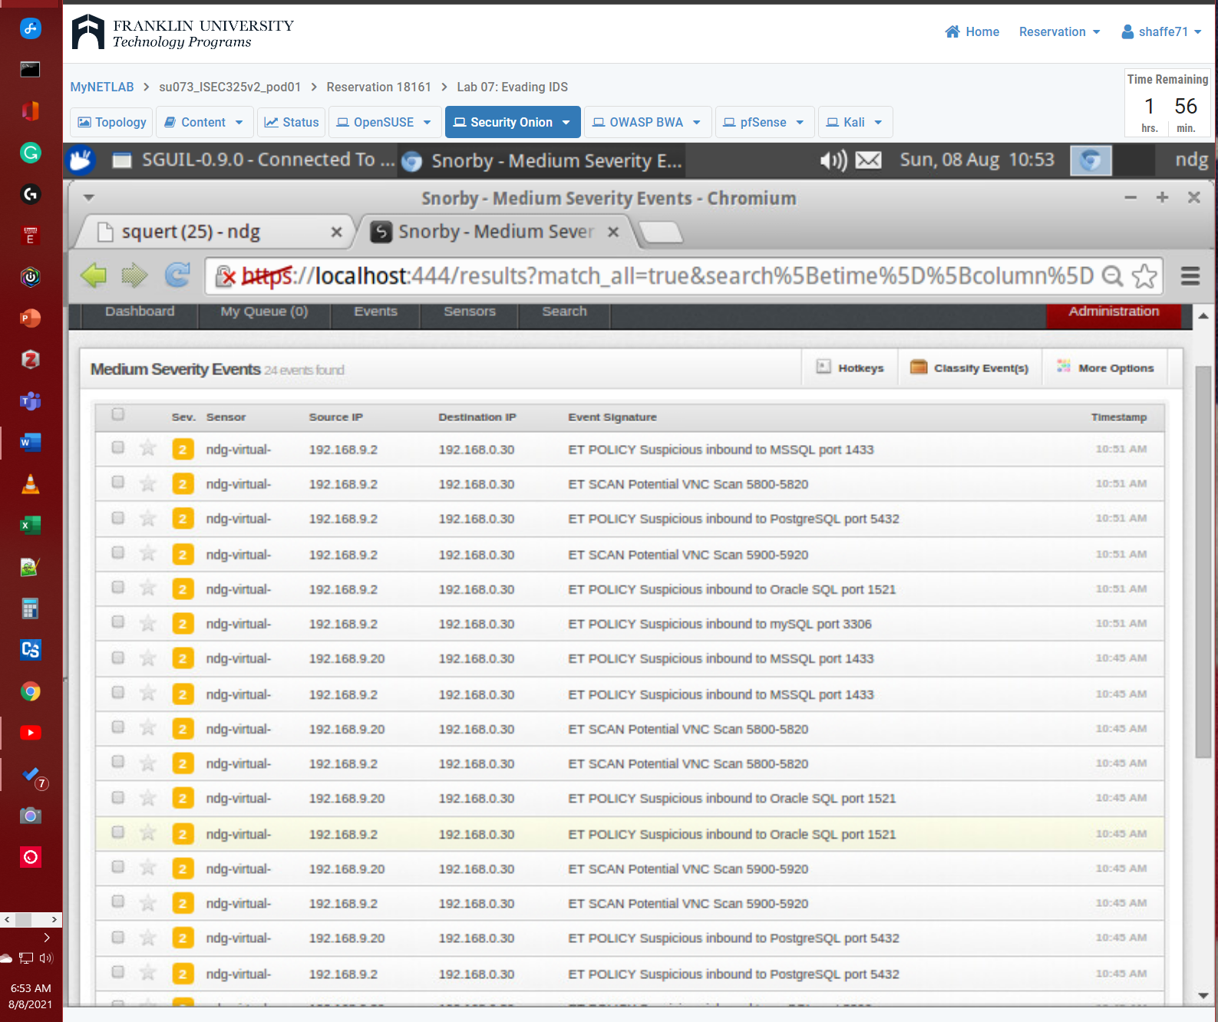

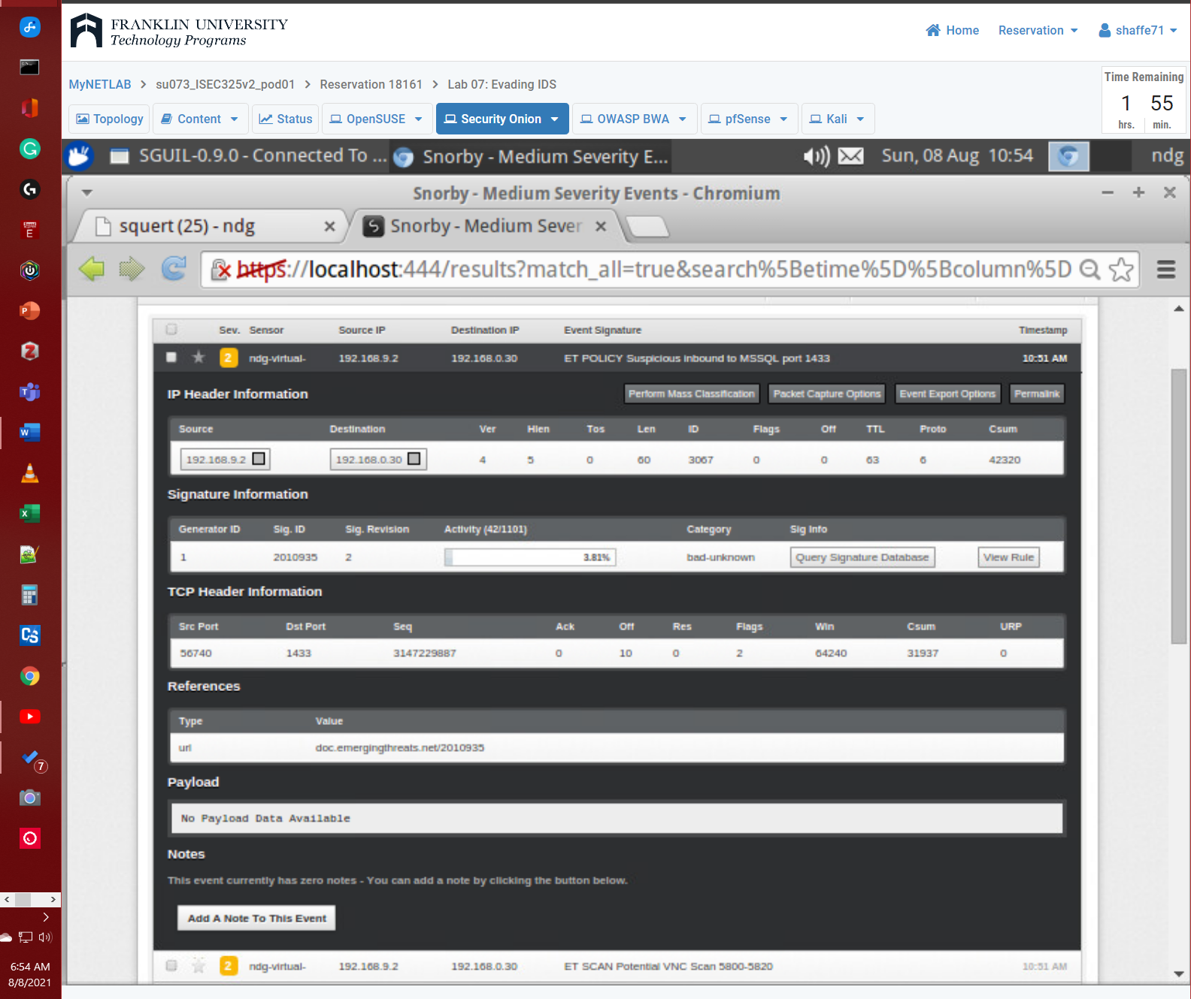

### Step 4 Squert output

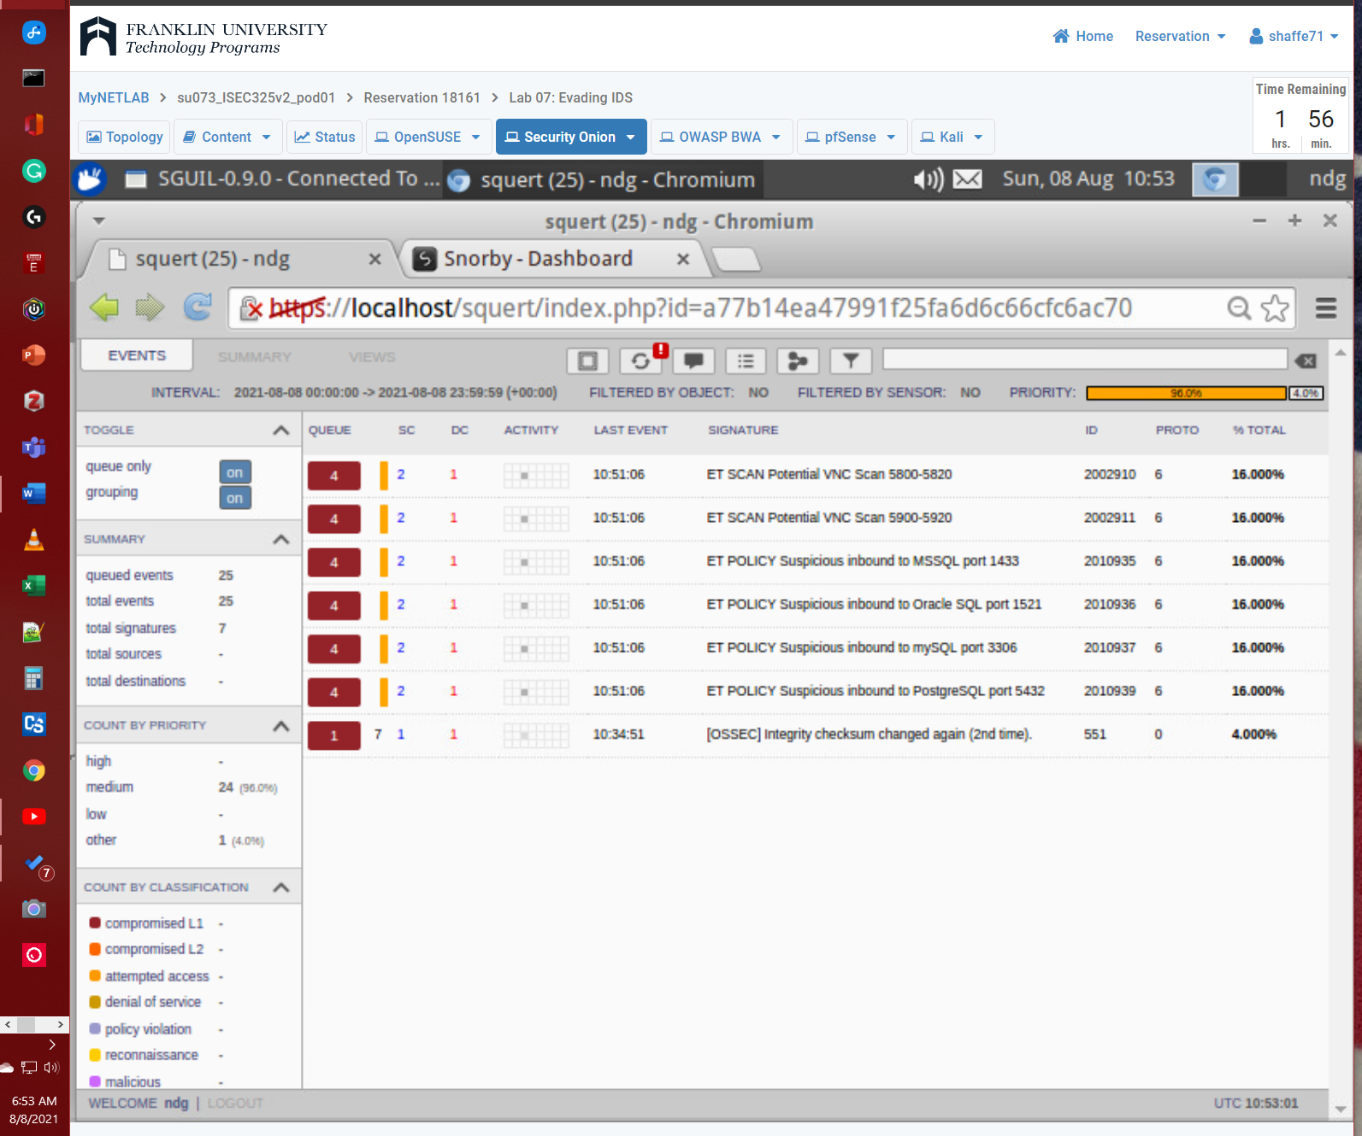

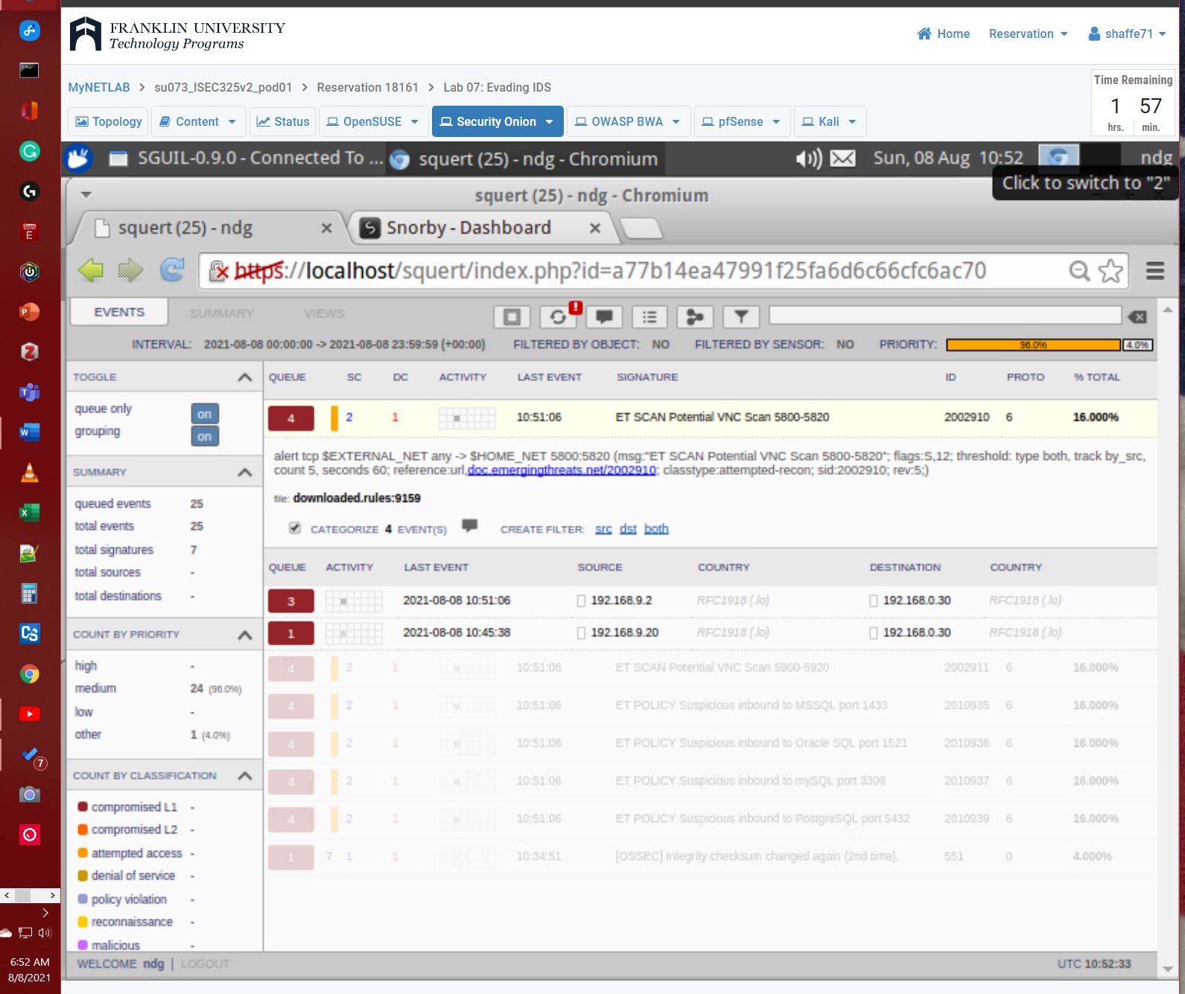

## Summary and Reflection: In a few paragraphs, reflect on what you learned through this lab assignment. Was there anything surprising or unexpected? Was there anything worth investigating further?Summary and Reflection: In a few paragraphs, reflect on what you learned through this lab assignment. Was there anything surprising or unexpected? Was there anything worth investigating further?

In lab 07 we learn evading IDS and monitoring using Sguil, Squert, and Snorby. Sguil is built by network security analysts for network security analysts that accesses realtime events, session data, and raw packet captures (*Sguil - Open Source Network Security Monitoring*, n.d.). Squert is a web application that query and view event data from Sguil database typically IDS alert data (*The Squertproject*, n.d.). Squert is a tool that attempts to provide additional context to events through the use of metadata, time series representations and weighted and logically grouped result sets (*The Squertproject*, n.d.). Snorby is a web GUI for managing your Snort system. The Snort daemon created in the last section will write all alerts to a Unified2 file, and Barnyard2 will process those alerts into a MySQL database. Snorby will let you browse, search, and profile those alerts from the database in a easy to view way. “Snorby is a modern Snort IDS frontend. The basic fundamental concepts behind Snorby are simplicity and power. The project goal is to create a free, open source and highly competitive application for network monitoring for both private and enterprise use” (Help Net Security, 2010).

We then used kali to run nmap to run a fragmented packet scan to locate open ports and services. Squert has found potential threats but Snorby or Sguil did not pick up any theats. Then we move on testing with Decoy Scan threw the nmap command. This time Squert and Snorby both picked up on the nmap scans both the decoy IP address and the kali VM IP address. Sguil only picked up the decoy IP adrdress. Then we test a spoofed mac scan through nmap. This time Squert and Snorby both picked up on the nmap scans both the spoofed mac IP address and the kali VM IP address. Sguil only picked up the spoofed mac IP adrdress. The resaults were not surprising that each can be beat by atleast one method but combined at least one will pick the scan. Due to the fact that they cover each other holes. I also did not find that I had any question.

# **References**

Help Net Security. (2010, December 7). Snorby: Modern Snort IDS frontend. *Help Net Security*. https://www.helpnetsecurity.com/2010/12/07/snorby-modern-snort-ids-frontend/

*Sguil—Open Source Network Security Monitoring*. (n.d.). Retrieved August 8, 2021, from https://bammv.github.io/sguil/index.html

*The Squertproject*. (n.d.). Retrieved August 8, 2021, from http://www.squertproject.org/home